Wang Dong Xu 王东旭
The Capriccio of the Mountain Folk Song 山谣随想
Errata List

*** All issues marked in pink.

General changes include:
- Font and format changes, including use of small time signatures, as agreed by SCO.
- Extending of trill line for the note duration.
- Extending slur to the end of a tied note.
- Added English names/text for instruments.
- Added missing fermatas to other parts.
- Rehearsal mark at the start has been removed.
For such edits I have marked some of these in pink but haven’t described them in the errata list below.

Errata from Version 4
Bar | Instrument | Issue | Answer
All | All | For the grace notes – are these acciaccaturas? (In which case I would add the slash and also slur them to the main note.
1 | All | Removed Rehearsal A, given that it is the start of the piece. Is that okay?
17 | Di, Suona | I added (mf) since the rest of the orchestra goes to this dynamic. I understand the next dynamic fo these notes is f so I’d like to check if you intend for the crescendo to continue till the f (beat 2).
24 | Winds | Added mf here to match plucked strings.
30 | Percussion | What’s the dynamic here?
68-69 | Bass | I changed the 1st note of bar 69 from A natural to A#. Is this correct?
112 | Winds | Should these also be ff ?
128 | Upper strings | Should these notes also have a gliss. line like the previous two bars?
140 | Harp | Is it okay if we remove harp pedalling text/diagram and pedal changes as these can be in the parts but not needed in the score.
146-47 | Dizi solo | Is there supposed to be one slur for this entire figure like this:  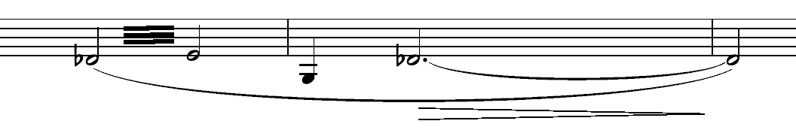  Or something more like this:  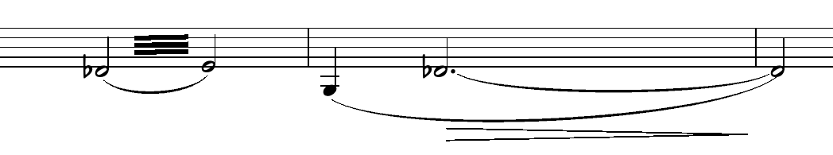
204-05 | Harp | Added beats for clarity.
206 | Perc III | Added ff here
228 | Perc II | Can I confirm that 小钟琴= Kalimba
255 | Dizi solo | Does this trill continue to the end of the next note?
264-75 | Perc I | Moved the notes up to be at the line. Was previously below the line.
275 | Dizi solo | Changed the tie from the tremolo to the next note to a dotted tie, given that the next note is on a new breath. I can also make it a bracketed tie, let me know if you have a preference!
291 | Erhu | Changed the grace note to acciaccatura to match Gaohu.
292 | GYSh | Adjusted crescendo to match other instruments.
299 | Cb. | Do you want a crescendo here like the other strings?
301 | Dizi solo | Should this note also be sf?

